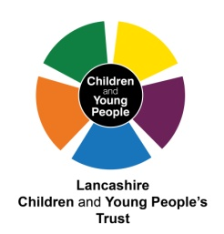
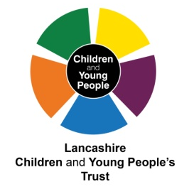
Lancashire Children and Young People’s Trust
May 2012

STRENGTHENING THE RELATIONSHIP WITH
THE HEALTH AND WELLBEING BOARD

Purpose
To provide an overview of the Lancashire Children and Young People's Trust and to outline recommendations that will support an effective and robust relationship between this partnership and the Health and Wellbeing Board.
What is a Children and Young People's Trust?
A local partnership which brings together the organisations responsible for services for children, young people and families
Context for the Lancashire CYP Trust

- 280,000 children and young people (0-19yrs)
- Estimated 80,000 children’s workforce
- 2011/2012 CYP budget for Lancashire £1,244 million – LCC, schools, police and health
- 1 overarching CYP Trust supported by 12 District CYP Trusts
- 633 schools, 162,000 pupils, 14% eligible for free school meals, 4% statement for special educational needs, 9% with a first language that is not English
- 1334 CYP in the care of the local authority

Who are our partners?

- Borough/District Councils
- Children’s Centres
- Colleges
- Health – commissioners and providers
- Lancashire Constabulary
- Lancashire County Council
- Lancashire Fire and Rescue Service
- Schools – primary, secondary and special
- Voluntary Community and Faith Sector

Strategies that underpin the work of the CYP Trust

There are many strategies that guide and direct our work with children and young people in Lancashire and whether these sit within individual sectors or organisations or cover a cross section of partners they will each provide a part of the context for how we want to improve outcomes. However, as partners working together within our CYP Trust arrangements, there are three key documents that articulate our aspirations for collaborative working. These are:
Lancashire Children and Young People's Plan (CYPP) 2011-2014 – this details what we want to achieve and the outcomes we want to improve for children and young people through working in partnership. It is informed through a significant and robust evidence base through data, information and intelligence including the CYP Joint Strategic Needs Assessment and consultation with 3500 children and young people. The two specific health priorities within the CYPP are:
- Lancashire babies are born healthy and have the best possible physical and emotional start in life.
- Children and young people's health and wellbeing is improved through healthy lifestyle choices.
Transforming Service Delivery – the vision for how we want to improve our services for children and young people. The principles shared locations; shared information; shared ownership; shared pathways; shared delivery/commissioning have been agreed and endorsed by all partners through the Lancashire CYP Trust and decisions about planning, commissioning and delivery of services for children and young people should be underpinned by these.
CYP Trust Strategic Action Plan – the overarching priorities for the CYP Trust that will embed the principles within the Transforming Service Delivery vision and deliver the priorities and outcomes of the CYPP.
Priorities for the work of the CYP Trust – 'Working Together'
At a meeting of the Lancashire CYP Trust Board in December 2011 there was agreement to four priorities that would form the basis of a strategic action plan. These priorities will drive our partnership approach across County and District Trust structures and provide a focus in delivering our Children and Young People's Plan. The priorities are:

- Continuum of Need
- Transforming Service Delivery
- Early Support
- Complex Families

These priorities will be developed within a framework of new ways of working that fundamentally changes and improves our whole approach to working with children, young people and families. Working with families as opposed to doing to, helping them to improve their situation and take greater control over changing their circumstances and improving outcomes for their children.
Where are we now?
- Although it is no longer a statutory requirement to maintain our Trust arrangements, in Lancashire all partners have strongly committed to working in partnership in this way and have ensured resources and capacity to enable this.
- 77% of the measures in the Children and Young People's Plan have shown an improvement on performance in the same period last year. There is still some outstanding health data that has not yet been published and will be available for inclusion when progress is next reported.
- Feedback from the recent Ofsted inspection of safeguarding and looked after children services highlighted a number of strengths of the Lancashire CYP Trust including 'outstanding strategic multi agency leadership with clear priorities and aspirations and a shared focus on improving outcomes for children and young people'.
- The Safeguarding Peer Review in July 2011 identified as a strength an 'embedded culture of partnership and multi agency working at county and district level, driven through fit for purpose children's trust arrangements'.

Recommendations
The following recommendations are proposed to build on the existing work of the CYP Trust; to strengthen the relationship between the Trust and the Health and Wellbeing Board and to reduce the risk of duplication in how we deliver services to children and young people.
- The CYP Health and Wellbeing Priority Group is established as a sub group of both the Trust and the Health and Wellbeing Board with a remit to promote, improve and champion the health and wellbeing of CYP (see appendix 1)
- The Director of Public Health to chair the CYP Health and Wellbeing Board Priority Group to ensure an appropriate flow of discussion, decision and information between the Priority Group and the HWB Board
- To establish a children and young people's version Health and Wellbeing Board whose membership will consist of children and young people from across Lancashire. This group will ensure and enable the voice, participation and engagement of children and young people in strategic decision making about health and wellbeing.
- A protocol will be drafted to formally outline the relationship and responsibilities between the CYP Trust and the Health and Wellbeing Board and building on the above recommendations. This will be presented for discussion and agreement at a future meeting.

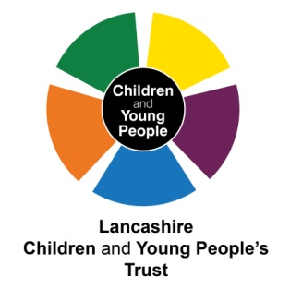
Appendix 1 - Lancashire Children and Young People's Trust Model
Lancashire Children and Young People's Trust Board
Lancashire Children and Young People's Trust Partnership
Safe from Harm Priority Group
Contribute and Engage Priority Group
Aspire and Achieve Priority Group
Health and Wellbeing Priority Group
Health and Wellbeing Board
District Children and Young People's Trust Priorities
Joint Commissioning Unit

CYP version of the Health and Wellbeing Board

